**作业一**

**题目**

重画五星红旗

----------------------------------------------------------------------------------------------

**源代码**

import turtle

""" turtle.speed(0)

turtle.delay(0) """

#无痕调整画笔坐标

def Go(x,y) :

    turtle.penup()

    turtle.goto(x,y)

    turtle.pendown()

#传入朝向画小五角星

def DrawSmallStar(degree):

    turtle.seth(degree)

    turtle.fillcolor("yellow")

    turtle.pencolor("yellow")

    turtle.begin_fill()

    for i in range(5):

        turtle.forward(38.0417418)

        turtle.right(144)

    turtle.end_fill()

#绘制大五角星

def BigStar() :

    turtle.pencolor("yellow")

    turtle.fillcolor("yellow")

    turtle.begin_fill()

    turtle.setheading(288)

    for i in range(5):

        turtle.forward(120)

        turtle.right(144)

    turtle.end_fill()

#画国旗大小600*400

turtle.pencolor("red")

turtle.fillcolor("red")

turtle.begin_fill()

Go(-300,200)

turtle.goto(300,200)

turtle.goto(300,-200)

turtle.goto(-300,-200)

turtle.goto(-300,200)

turtle.end_fill()

#绘制大五角星

Go(-200,160)

BigStar()

#第一个小五角星

Go(-100 - 17.3145, 160 - 6.174)

DrawSmallStar(48.96347)

#第二个小五角星

Go(-60 - 19.7948663580, 120 - 2.857143)

DrawSmallStar(36.213211)

#第三个小五角星

Go(-60 - 19.5, 60 + 5.714285848)

DrawSmallStar(5)

#第四个小五角星

Go(-100 - 17.2, 20 + 15.99999)

DrawSmallStar(-35.1301)

turtle.hideturtle()

turtle.done()

----------------------------------------------------------------------------------------------

**运行结果**

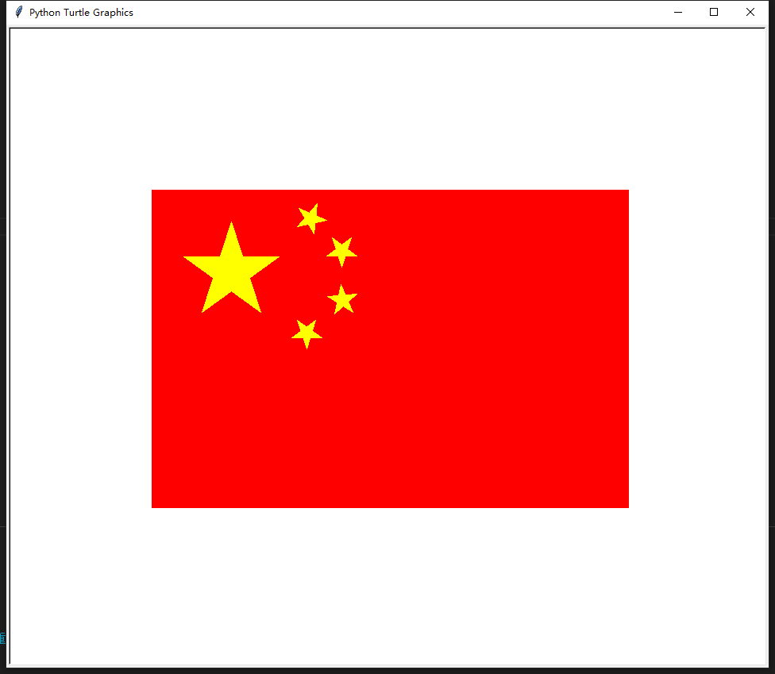

----------------------------------------------------------------------------------------------

**作业二**

**题目**

DrawArrow

----------------------------------------------------------------------------------------------

**源代码**

import turtle

import random

def drawArrow() :

    turtle.left(150)

    turtle.forward(15)

    turtle.backward(15)

    turtle.left(60)

    turtle.forward(15)

    turtle.backward(15)

cnt = int(input("请输入画线次数"))

turtle.backward(300)

turtle.forward(600) #x轴

turtle.write("x")

drawArrow()

turtle.home()

turtle.left(90) #y轴

turtle.backward(300)

turtle.forward(600)

turtle.write("y")

drawArrow()

turtle.home()

for i in range(cnt) :

    length = random.randint(50,400)

    direction = random.randint(0,360)

    turtle.setheading(direction)

    turtle.forward(length)

    drawArrow()

    turtle.home()

turtle.done()

----------------------------------------------------------------------------------------------

**运行结果**

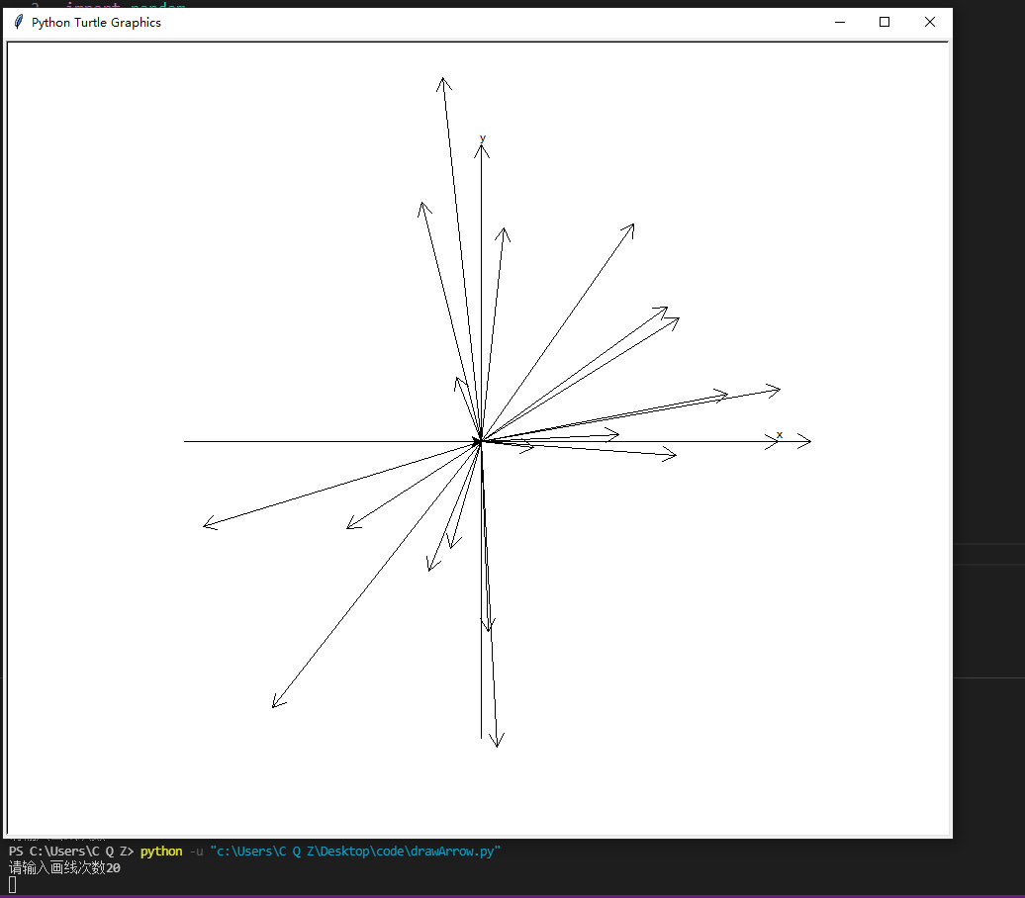

----------------------------------------------------------------------------------------------

**作业三**

**题目**

画美国国旗

----------------------------------------------------------------------------------------------

**源代码**

import turtle

def drawSquar():  # 画国旗的红条纹

    turtle.goto(300,175)

    turtle.setheading(180)

    turtle.color('#B22234')

    turtle.begin_fill()

    for i in range(7):

        turtle.forward(600)

        turtle.left(90)

        turtle.forward(350 / 13)

        turtle.left(90)

        turtle.forward(600)

        turtle.right(90)

        turtle.forward(350 / 13)

        turtle.right(90)

    turtle.end_fill()

def drawSmallsqure():  # 画国旗左上角的蓝色矩形

    turtle.color('#3C3B6E')

    turtle.begin_fill()  # 开始填充

    turtle.left(90)

    turtle.forward(350 / 2)

    turtle.left(90)

    turtle.forward(300)

    turtle.left(90)

    turtle.forward(350 * 7 / 13)

    turtle.left(90)

    turtle.forward(300)

    turtle.end_fill()  # 填充结束

def drawStarsInLine(x,y,num) : # 画每行的小星星

    for i in range(num):    # 每行画num个星星

            turtle.goto(x, y)

            turtle.color('white')

            turtle.begin_fill()

            turtle.setheading(108)

            for j in range(5):  # 画每一个星星

                turtle.left(144)

                turtle.forward(20)

            x -= 50

            turtle.end_fill()

def drawStars():  # 画左上角的小星星，七行，四行六个，三行五个

    x = -25

    y = 10

    for i in range(4):  # 画四行 每行六个星星

        drawStarsInLine(x,y,6)

        y += 350 / 13 * 2

    x = -50

    y = 350 / 13 +10

    for i in range(3):  # 画三行 每行五个

        drawStarsInLine(x,y,5)

        y += 350 / 13 * 2

def main() :

    turtle.setup(1000.0, 600.0)

    turtle.speed(0)

    turtle.penup()  # 隐藏画笔画出的线 只要填充的色块即可

    drawSquar()  # 画国旗的条纹

    turtle.home()

    drawSmallsqure()  # 画国旗左上角的小矩形

    turtle.home()

    drawStars()  # 画左上角的小星星

    turtle.hideturtle()

    turtle.done()

main()

--------------------------- -------------------------------------------------------------------

**运行结果**



